**DSA Assignment – 22nd July**

**Name – Karan Joshi**

**Roll No. – 23/11/EC/036**

**Leetcode Id – Karan_Joshi068048**

**Geeksforgeeks Id – wwwjoshikaran3424**

**Github Repo Link -** [**https://github.com/KaranJoshi101/urban-octo-robot/**](https://github.com/KaranJoshi101/urban-octo-robot/)

DSA-Section -

Question 1: Merge Sort

Submission Screenshot:

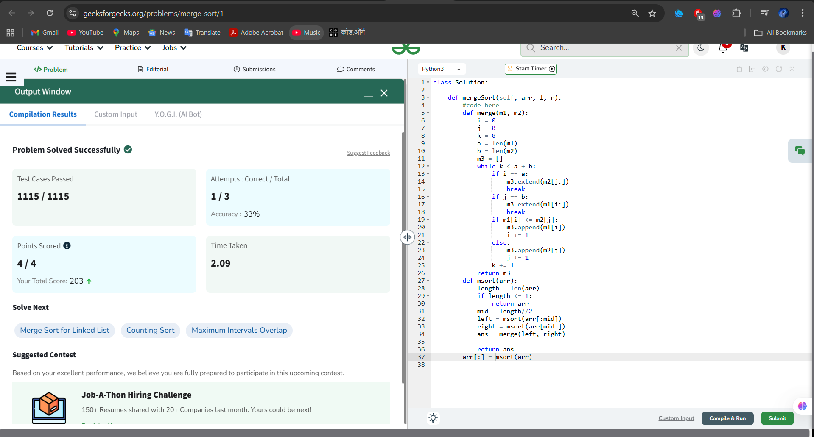

Question 2: Quick Sort

Submission Screenshot:

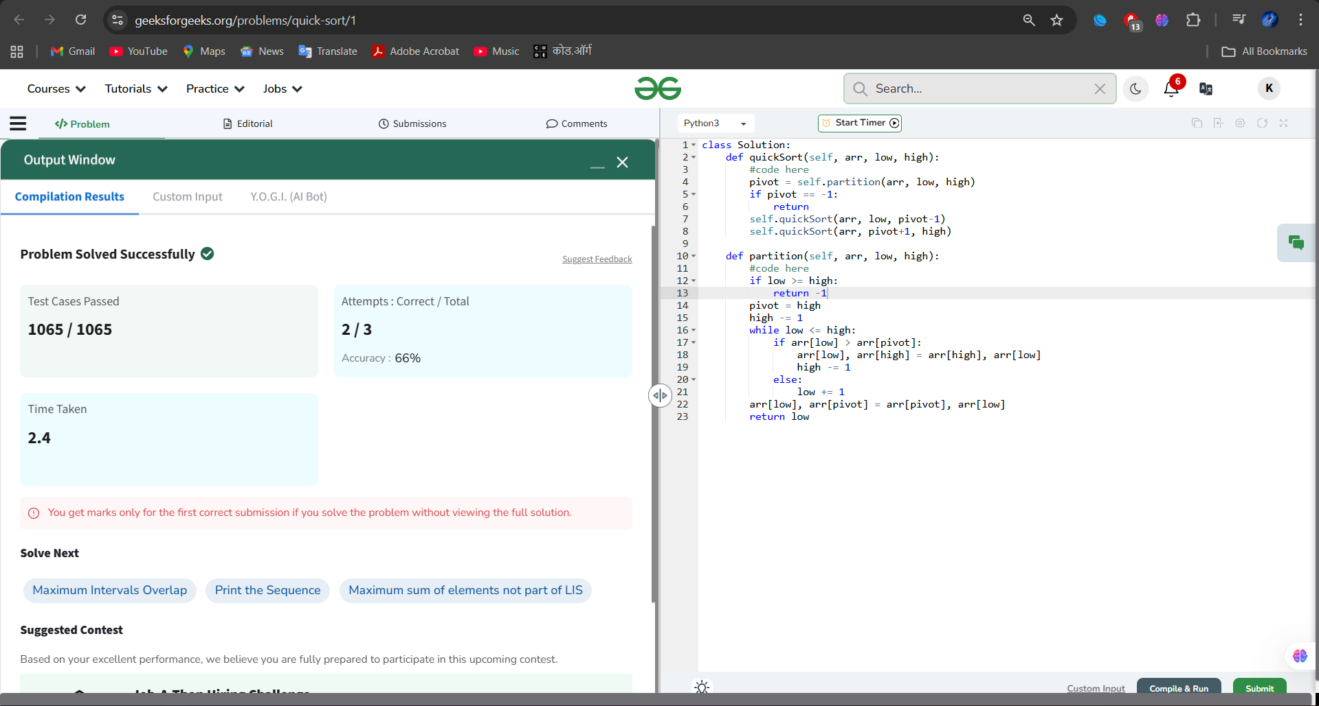

Question 3: Find Position

Submission Screenshot:

